SETTINGUPAPPLICATIONENVIRONMENT

INSTALLIBMCLOUD CLI

|  |  |
| --- | --- |
| **DATE** | **24OCT2022** |
| **TEAM ID** | **PNT2022TMID30749** |
| **PROJECTNAME** | **SKILLANDJOBRECOMMENDERAPPLICATION** |
| **TEAMMEMBERS** | **Bavadharshini, Harishni, Madhumitha.A, Madhumitha K, Monisha** |

# STEP 1

LogintoyourIBMCloud[***https://cloud.ibm.com/login***](https://cloud.ibm.com/login)andin-searchbaryoucantype

Containerregistryandclicktogetstarted.

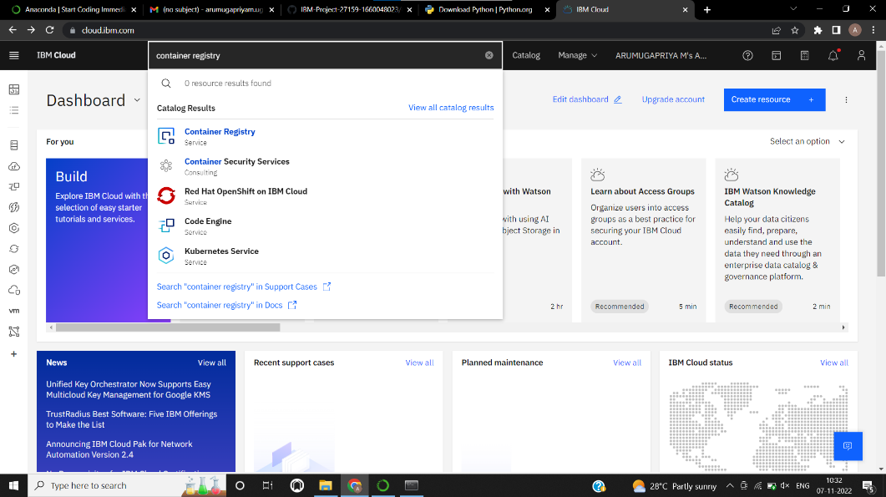

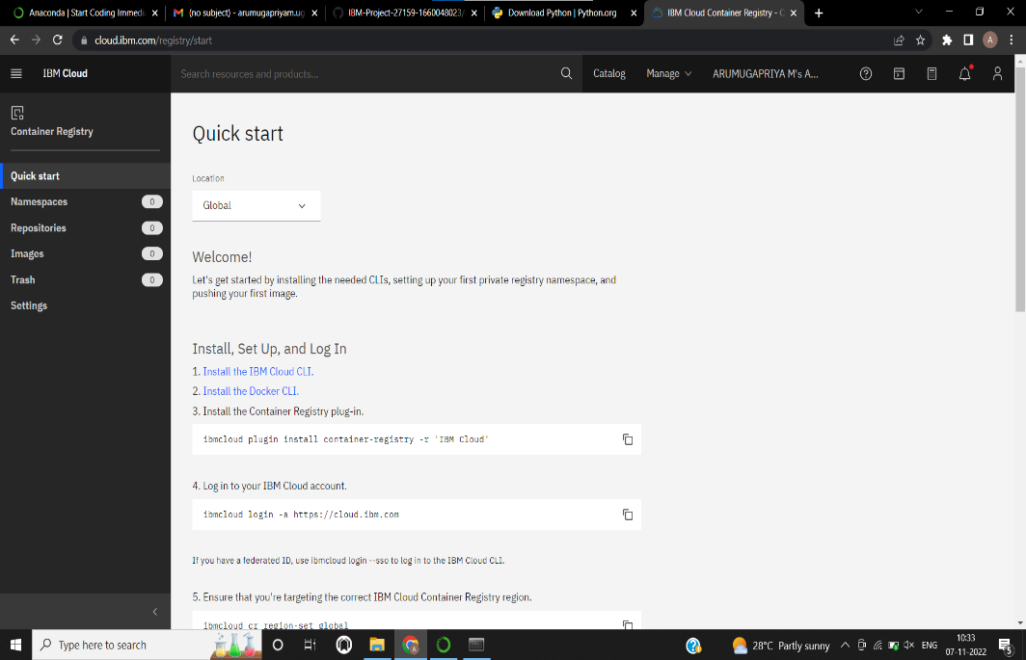

# STEP 2

Followanddo thestepgivenin thispage onebyone[***https://cloud.ibm.com/registry/***](https://cloud.ibm.com/registry/%20start)

[start](https://cloud.ibm.com/registry/%20start)

# STEP 3

Runthecommandinpowershell,

(New-ObjectNet.WebClient).DownloadString('https://clis.cloud.ibm.com

/install/powershell')

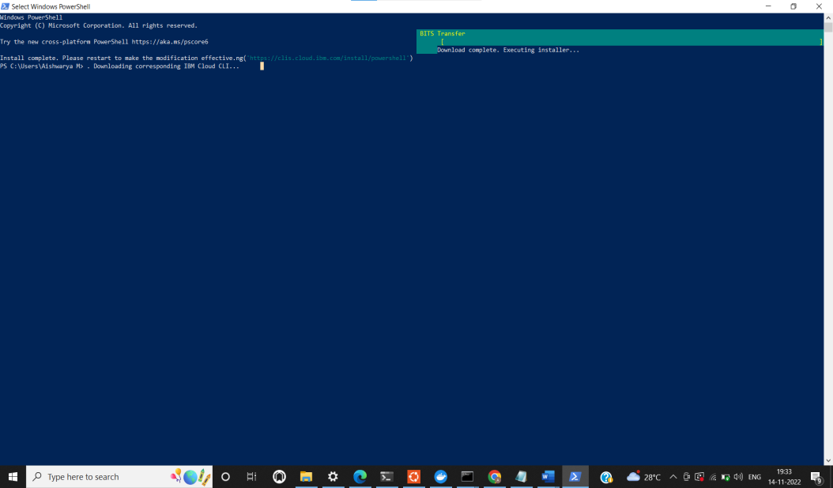

# STEP 4

Runallthe commandonebyonein cmd

<https://cloud.ibm.com/docs/containers?topic=containers-cs_cli_install>

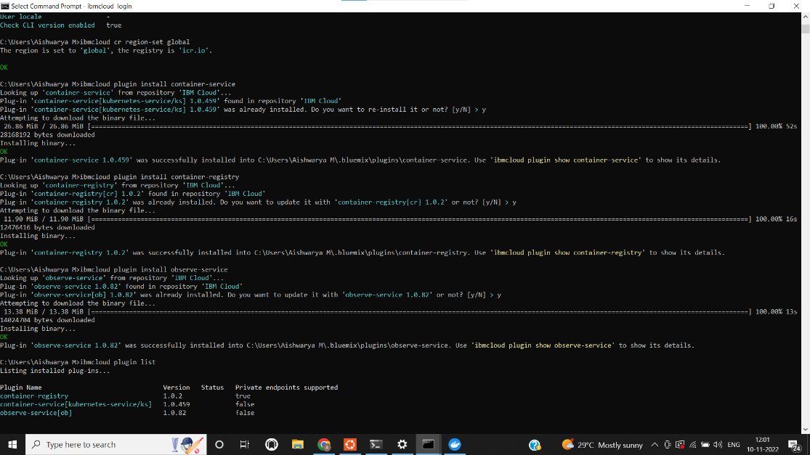

# STEP 6

Finally,youwillgettheIBMCLOUDCLIin yourdesktop